CYCLE-4
1. Using the iris data set implement the KNN algorithm. Take different values for Test and training data set .Also use different values for k. Also find the accuracy level.
Program
import numpy as np
import matplotlib.pyplot as plt
import seaborn as sns
import pandas as pd
irist = sns.load_dataset('iris')
dataset = pd.DataFrame(irist)
dataset.head()
X = dataset.iloc[:, :-1].values
y = dataset.iloc[:, 4].values
from sklearn.model_selection import train_test_split
X_train, X_test, y_train, y_test = train_test_split(X, y, test_size=0.30)
from sklearn.preprocessing import StandardScaler
scaler = StandardScaler()
scaler.fit(X_train)
X_train = scaler.transform(X_train)
X_test = scaler.transform(X_test)
from sklearn.neighbors import KNeighborsClassifier
classifier = KNeighborsClassifier(n_neighbors=5)
classifier.fit(X_train, y_train)
y_pred = classifier.predict(X_test)
from sklearn.metrics import classification_report, confusion_matrix
print(confusion_matrix(y_test, y_pred))
print(classification_report(y_test, y_pred))
output
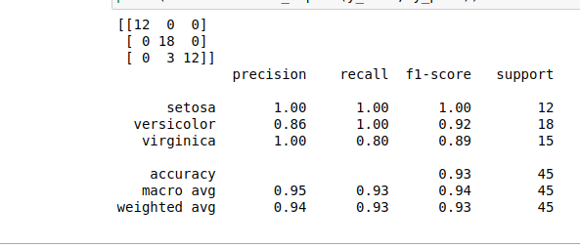

- Download another data set suitable for the KNN and implement the KNN algorithm. Take different values for Test and training data set. Also use different values for k.

CODE
import numpy as np
import matplotlib.pyplot as plt
import pandas as pd
dataset = pd.read_csv("cancer.csv")
dataset.head()
dataset.info()
X = dataset.iloc[:, 2:35].values
print(X)
y = dataset.iloc[:, 1].values
print(y)
from sklearn.model_selection import train_test_split
X_train, X_test, y_train, y_test = train_test_split(X, y, test_size=0.20)
from sklearn.neighbors import KNeighborsClassifier
classifier = KNeighborsClassifier(n_neighbors=5)
classifier.fit(X_train, y_train)
y_pred = classifier.predict(X_test)
from sklearn.metrics import classification_report, confusion_matrix
print(classification_report(y_test, y_pred))
from sklearn.metrics import accuracy_score
print ("Accuracy : ", accuracy_score(y_test, y_pred))
df = pd.DataFrame({'Real Values':y_test, 'Predicted Values':y_pred})
df

OUTPUT

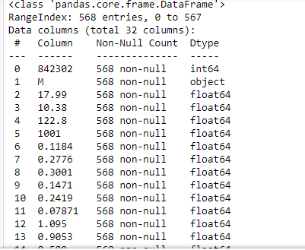
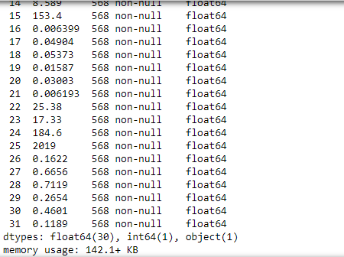
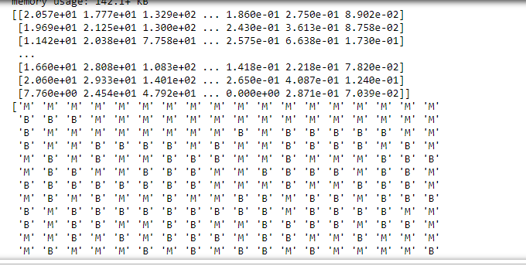

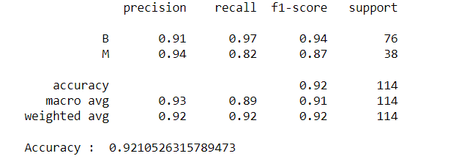
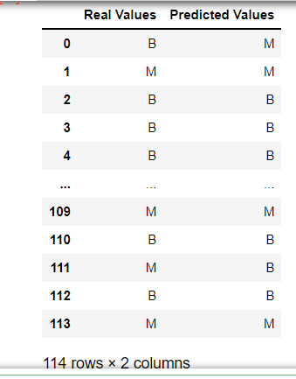

- Using iris data set, implement naive bayes classification for different naive Bayes classification algorithms. ((i) gaussian (ii) bernoulli etc)
- Find out the accuracy level w.r.t to each algorithm
- Display the no:of mislabeled classification from test data set
- List out the class labels of the mismatching records

i)CODE
import numpy as np
import matplotlib.pyplot as plt
import pandas as pd
dataset = pd.read_csv('iris.csv')
X = dataset.iloc[:,:4].values
y = dataset['variety'].values
dataset.head(5)
from sklearn.model_selection import train_test_split
X_train, X_test, y_train, y_test = train_test_split(X, y, test_size = 0.2)
from sklearn.naive_bayes import GaussianNB
classifier = GaussianNB()
classifier.fit(X_train, y_train)
y_pred = classifier.predict(X_test)
y_pred
from sklearn.metrics import confusion_matrix
cm = confusion_matrix(y_test, y_pred)
from sklearn.metrics import accuracy_score
print ("Accuracy : ", accuracy_score(y_test, y_pred))
cm
df = pd.DataFrame({'Real Values':y_test, 'Predicted Values':y_pred})
df

OUTPUT

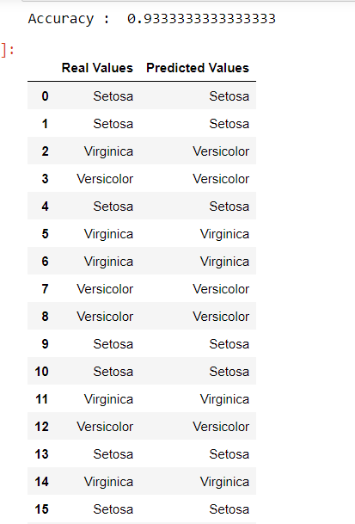
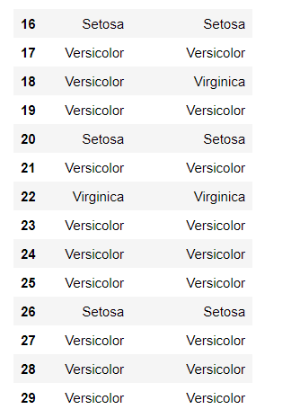

CODE
import numpy as np
import matplotlib.pyplot as plt
import pandas as pd
dataset = pd.read_csv('iris.csv')
X = dataset.iloc[:,:4].values
y = dataset['variety'].values
dataset.head(5)
from sklearn.model_selection import train_test_split
X_train, X_test, y_train, y_test = train_test_split(X, y, test_size = 0.2)
from sklearn.naive_bayes import BernoulliNB
classifier = BernoulliNB()
classifier.fit(X_train, y_train)
y_pred = classifier.predict(X_test)
y_pred
from sklearn.metrics import confusion_matrix
cm = confusion_matrix(y_test, y_pred)
from sklearn.metrics import accuracy_score
print ("Accuracy : ", accuracy_score(y_test, y_pred))
cm
# df = pd.DataFrame({'Real Values':y_test, 'Predicted Values':y_pred})
# df
OUTPUT
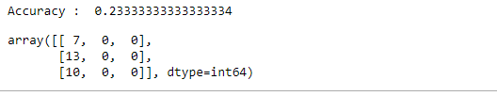
ii)CODE
import numpy as np
import matplotlib.pyplot as plt
import pandas as pd
dataset = pd.read_csv('iris.csv')
X = dataset.iloc[:,:4].values
y = dataset['variety'].values
dataset.head(5)
from sklearn.model_selection import train_test_split
X_train, X_test, y_train, y_test = train_test_split(X, y, test_size = 0.2)
from sklearn.naive_bayes import BernoulliNB
classifier = BernoulliNB()
classifier.fit(X_train, y_train)
y_pred = classifier.predict(X_test)
y_pred
#from sklearn.metrics import confusion_matrix
#cm = confusion_matrix(y_test, y_pred)
from sklearn.metrics import accuracy_score
print ("Accuracy : ", accuracy_score(y_test, y_pred))
#cm
df = pd.DataFrame({'Real Values':y_test, 'Predicted Values':y_pred})
df
OUTPUT
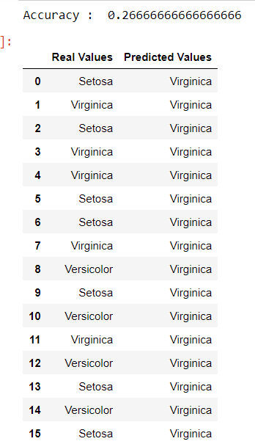
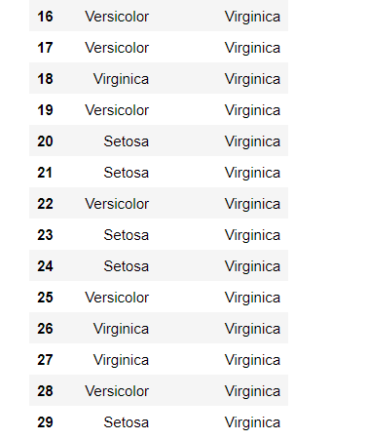
References:
https://towardsdatascience.com/machine-learning-basics-naive-bayes-classification-964af6f2a965

https://scikit-learn.org/stable/modules/classes.html#module-sklearn.naive_bayes

- Use car details CSV file and implement decision tree algorithm
- Find out the accuracy level.
- Display the no: of mislabelled classification from test data set
- List out the class labels of the mismatching records

References:
https://www.24tutorials.com/machine-learning/case-study-decision-tree-model-for-car-quality/
https://notebook.community/bMzi/ML_in_Finance/0210_DecisionTrees
https://stackabuse.com/decision-trees-in-python-with-scikit-learn/

For Data Sets Refer:

https://www.kaggle.com ( for data set)
http://archive.ics.uci.edu/ml/datasets.php

REGRESSION

Implement Simple and multiple linear regression for the data sets ‘student_score.csv’ and ‘company_data .csv’ respectively
Ref: https://stackabuse.com/linear-regression-in-python-with-scikit-learn/

Simple Linear Regression

import numpy as np
import pandas as pd
import matplotlib.pyplot as plt
#data set contains details of no.of hours spend by students for studt and their marks
student = pd.read_csv('student_scores.csv')
student.head()

student.describe()

OUTPUT:
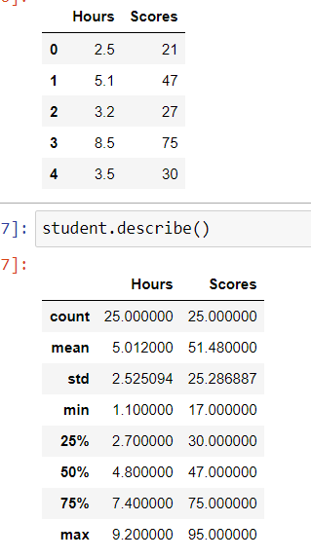

student.info()

OUTPUT:

<class 'pandas.core.frame.DataFrame'>
RangeIndex: 25 entries, 0 to 24
Data columns (total 2 columns):
# Column Non-Null Count Dtype
--- ------ -------------- -----
0 Hours 25 non-null float64
1 Scores 25 non-null int64
dtypes: float64(1), int64(1)
memory usage: 528.0 bytes

import matplotlib.pyplot as plt
Xax=student.iloc[:,0]
Yax=student.iloc[:,1]
plt.scatter(Xax,Yax)
plt.xlabel("No.of hours")
plt.ylabel("Score")
plt.title("Student scores")
plt.show()

OUTPUT:
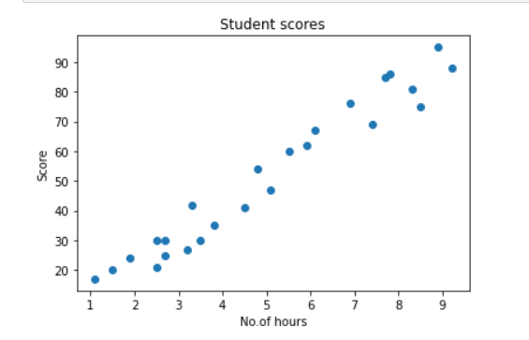

#Perform the simple linear regression model
#Equation: Y=w0+w1.x
#Here Y(marks)=w0+w1.x
#Create x as hours and Y as marks
X = student.iloc[:, :-1]
y = student.iloc[:, 1]
print(X)

OUTPUT:

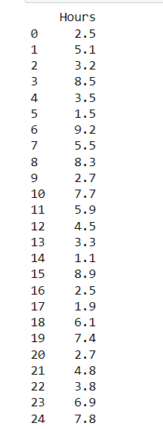

print(y)

OUTPUT:
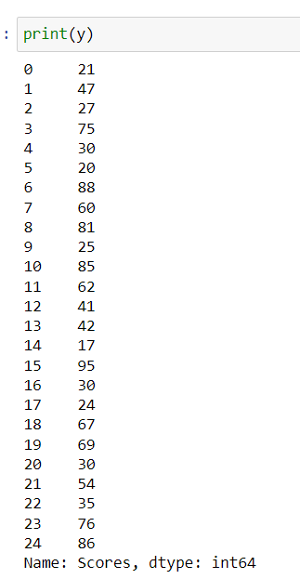

from sklearn.model_selection import train_test_split
X_train, X_test, y_train, y_test = train_test_split(X, y, test_size=0.2)
print(X_train)

OUTPUT:

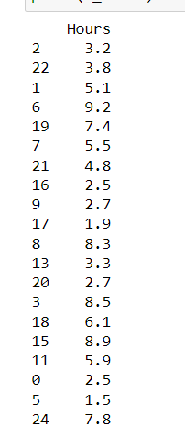

from sklearn.linear_model import LinearRegression
regressor = LinearRegression()
regressor.fit(X_train, y_train)

OUTPUT:
LinearRegression()

print(regressor.intercept_)

OUTPUT:
3.4157789720979608

print(regressor.coef_)

OUTPUT:
[9.544138]

y_pred = regressor.predict(X_test)
for(i,j) in zip(y_test,y_pred):
if i!=j:
print("Actual value :",i,"Predicted value :",j)
print("Number of mislabeled points from test data set :", (y_test != y_pred).sum())

OUTPUT:
Actual value : 76 Predicted value : 69.2703311556657
Actual value : 41 Predicted value : 46.36439996138126
Actual value : 85 Predicted value : 76.90564155376049
Actual value : 17 Predicted value : 13.914330769478324
Actual value : 30 Predicted value : 36.82026196376275
Number of mislabeled points from test data set : 5

from sklearn import metrics
print("Mean Absolute error :", metrics.mean_absolute_error(y_test,y_pred))
print("Mean Squared error :", metrics.mean_squared_error(y_test,y_pred))
print("Root Mean Squared error :", np.sqrt(metrics.mean_squared_error(y_test,y_pred)))

OUTPUT:
Mean Absolute error : 6.0188716892478995
Mean Squared error : 39.124239242163426
Root Mean Squared error : 6.254937189306014

import matplotlib.pyplot as plt
c=X_test['Hours'].count()
xax=np.arange(c)
print(xax)
X_axis = np.arange(len(xax))
plt.bar(X_axis-0.2, y_test, 0.6, label='Actual')
plt.bar(X_axis+0.2, y_pred, 0.6, label='Predicted')
plt.xlabel("Test Records")
plt.ylabel("Marks")
plt.title("Student Score prediction")
plt.legend()
plt.show()

OUTPUT:

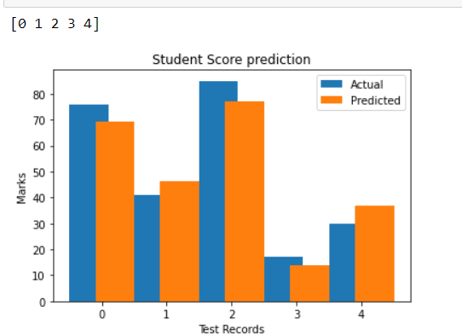

Multiple Linear Regression

